DAA Practical 6 – Matrix Chain Multiplication
Design and Analysis of Algorithms

Aim
To find the minimum number of scalar multiplications for a chain of matrices using Dynamic Programming.

Matrix Chain Multiplication

1. Algorithm
Algorithm: Matrix Chain Multiplication (Dynamic Programming)

Aim:
To find the minimum number of scalar multiplications needed to
multiply a chain of matrices.

Input:
- Array of matrix dimensions p[]
Example: [10, 30, 5, 60] means matrices
A1(10x30), A2(30x5), A3(5x60)

Output:
- Minimum multiplication cost
- Execution time and complexity

Steps:
1. Start
2. Read dimension array p[] of size m
3. Set n = m - 1 (number of matrices)
4. Create DP table dp[n][n]
5. Set dp[i][i] = 0 for all i (one matrix needs 0 multiplications)
6. For length = 2 to n, repeat steps 7 to 12
7. For i = 0 to n - length, repeat steps 8 to 12
8. Set j = i + length - 1
9. Set dp[i][j] = infinity
10. For k = i to j - 1, repeat steps 11 to 12
11. cost = dp[i][k] + dp[k+1][j] + p[i]*p[k+1]*p[j+1]
12. If cost < dp[i][j] then dp[i][j] = cost
13. Minimum cost = dp[0][n-1]
14. Print minimum cost
15. Stop

Idea:
Try every possible place to split the chain.
Keep the split that gives the lowest cost.
Use already computed smaller chains from the DP table.

Example:
Dimensions = [10, 30, 5, 60, 20, 10]
Matrices: 10x30, 30x5, 5x60, 60x20, 20x10
Minimum multiplications = 9000

Time Complexity: O(n^3)
Space Complexity: O(n^2)

2. Program Code (C Language)
File: Code/matrix_chain.c
#include <stdio.h>
#include <limits.h>
#include <time.h>

/*
Matrix Chain Multiplication using Dynamic Programming
Find minimum cost to multiply a chain of matrices
*/
int matrixChainOrder(int p[], int n)
{
// n = number of matrices = len(p) - 1
int dp[n][n];
int i, j, k, length, cost;

// cost of one matrix is 0
for (i = 0; i < n; i++)
dp[i][i] = 0;

// length = size of chain (2, 3, 4, ...)
for (length = 2; length <= n; length++)
{
for (i = 0; i < n - length + 1; i++)
{
j = i + length - 1;
dp[i][j] = INT_MAX;

// try every split position k
for (k = i; k < j; k++)
{
cost = dp[i][k] + dp[k + 1][j]
+ p[i] * p[k + 1] * p[j + 1];

if (cost < dp[i][j])
dp[i][j] = cost;
}
}
}

return dp[0][n - 1];
}

int main()
{
int m, i;
clock_t start, end;

// m = number of dimension values
// for 5 matrices we need 6 numbers
printf("Enter number of dimension values: ");
scanf("%d", &m);

int dimensions[m];

printf("Enter %d dimensions:\n", m);
for (i = 0; i < m; i++)
scanf("%d", &dimensions[i]);

int n = m - 1; // number of matrices

start = clock();
int min_cost = matrixChainOrder(dimensions, n);
end = clock();

printf("\nMatrix Chain Multiplication\n");
printf("--------------------------------\n");
printf("Matrix dimensions: ");
for (i = 0; i < m; i++)
printf("%d ", dimensions[i]);
printf("\n");
printf("Minimum number of scalar multiplications: %d\n", min_cost);
printf("Execution time: %.8f seconds\n",
(double)(end - start) / CLOCKS_PER_SEC);
printf("\nTime Complexity: O(n^3)\n");
printf("Space Complexity: O(n^2)\n");

return 0;
}

3. Output
Sample program output:
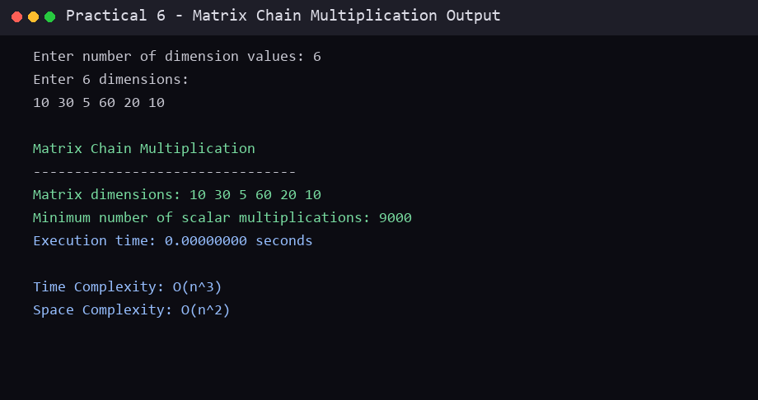

Conclusion
In this practical, the required algorithm(s) were studied and implemented successfully in C. The algorithm, program code and sample output are recorded above. This practical helped in understanding the working, advantages and complexity of the technique(s) used.
End of Practical 6

